***Attacking Pluto***

**The general idea of the game:**

Attacking Pluto is a 2D space shooter game in which the player is in a space ship. The Earth is slowly being destroyed by people and the only place where survival is possible is the planet Pluto. Unfortunately there are a lot of aliens there. In order to survive, the main character called “Iskren” has to kill every living organism on this planet to make it a safe place for living.

**1. Inspiration:**

**-They crawled from Uranus**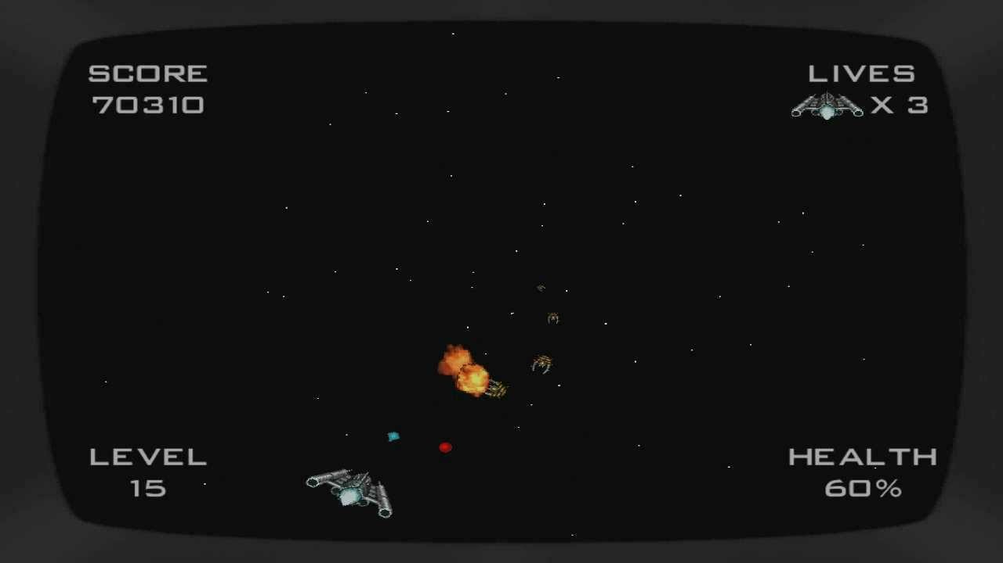

**-MICSHOOTER**

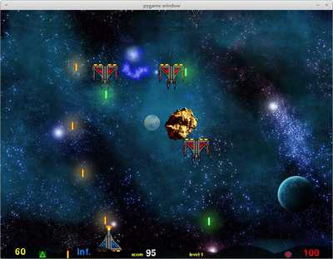

**-Xenoraid**

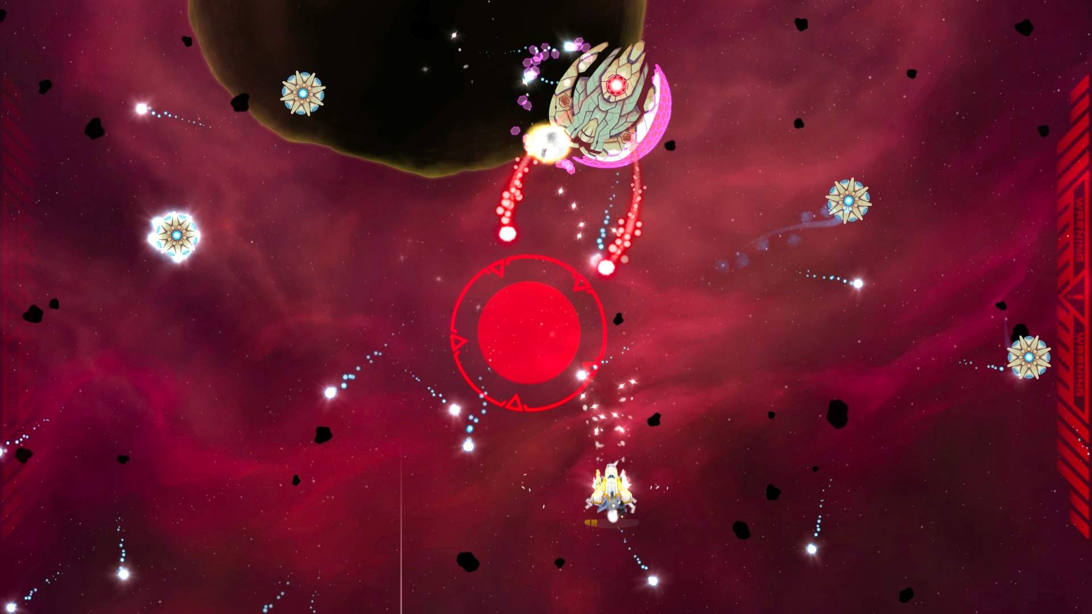

**2. Characters:**

-The main character in the game is “Iskren”. He travels to Pluto in his spaceship.

-The first wave of enemies that attack him are 3 different kinds of aliens:

*EyeLicker – A giant eyeball with a tongue ready to lick the life out of Iskren’s spaceship.

*BIRD(Big Irritated Red Dragon) – He is the biggest alien in the first level of the game. His wings are very big (the size of 2 Boeing 747’s).

*batGergi – A small but fearless bat that tries to spread coronavirus. His claws can ruin even the strongest space ship.

*TheMedusaMini and TheMedusaNotSoMini are the aliens from the second level. They are equipped with BBC (big blue comets). They shoot them every second, so they are hard to escape!

*BigBrainBoss – This is the final boss that appears at level 3. He shoots 3 green comets at your ship. He is the most unpredictable and hard to kill enemy in the whole game.

**3. Story:**

In a distant future, humanity faced a grave crisis. The planet Earth, once abundant with life, had been devastated by the relentless destruction caused by its own inhabitants. Pollution and war had rendered the once thriving world inhospitable, and the survival of the human race was at stake.

In their search for a new home, scientists and explorers set their sights on the outer reaches of the solar system. They discovered that Pluto, once regarded as a distant and icy dwarf planet, held the key to their survival. Its desolate surface harbored precious resources and had the potential to sustain human life.

The responsibility of ensuring humanity's future fell upon the shoulders of a brave pilot named Iskren. He was chosen for his unparalleled skills and unwavering determination. Iskren was an expert in combat and navigation, making him the perfect candidate for the dangerous mission ahead.

Equipped with a state-of-the-art spacecraft, Iskren embarked on a treacherous journey to Pluto. The voyage itself was a hard one, filled with perilous asteroid fields and unpredictable cosmic storms. But Iskren remained resolute, focused on the mission that could save his people.

Upon reaching Pluto, Iskren discovered that the once barren landscape was now teeming with extraterrestrial life. The aliens, driven by their insatiable hunger for conquest, had sought to claim Pluto for themselves. Their advanced technology and formidable armadas posed a grave threat to humanity's last hope.

The aliens were cunning and relentless, but Iskren's determination remained unshaken. He analyzed their strategies, honed his piloting skills, and adapted his tactics to exploit their weaknesses. Each encounter brought him closer to his ultimate goal of eliminating the alien threat and securing a new home for humanity.

With renewed purpose, Iskren pushed himself beyond his limits, engaging the alien forces in a final, climactic battle. He had to face the alien boss – BigBrainBoss.

Iskren's name became legend, an inspiration for generations to come. His sacrifice and courage paved the way for the survival of humanity, a testament to the indomitable spirit of those who dared to fight for a better future.

And so, the tale of Iskren, the hero who vanquished the alien threat on Pluto, became etched in the annals of human history, a reminder of the resilience of the human spirit and the importance of cherishing and preserving our precious home.

**4. Theme:**

From Earth's ruin to Pluto's salvation, one pilot's courage determines humanity's fate. Facing alien conquest, Iskren fights to secure a new home, inspiring future generations with his indomitable spirit. Survival hangs in the balance as heroes rise, cherishing and preserving our precious world.

**5. Gameplay:**

**5.1. Goals:**

The main goal of the game is to kill all the aliens in order to make Pluto a safe place to live.

**5.2. Player skills:**

-The player can shoot the aliens with his blaster gun.

-The player can dodge the aliens and their magic spells (the aliens at level 2 can cast a magic spell that takes 1 life from the player’s 3 lives)

**5.3. Losing:**

The player has 3 lives, when he gets hit by an alien or it’s magic spell, he loses 1 life. It does not matter if the player dies 1 or 2 times, because when he gets to the next level the hearts return to 3. However, he gets respawned in another time zone (10 years later) which slows his mission! If the player dies 3 times, the mission fails and death menu screen appears. You can try again

**6. Art style:**

This is 2D space shooter game with high quality animated sprites. The characters are made from various artists. Everything is very colorful and looks alive, the background is also moving as the player flies through space.

**7. Music and sounds:**

-No source, downloaded randomly from various websites.

**8. Technical description:**

Initially, the game will be for PC only.

**9. Demographics:**

Age: 0 to 999

Sex: Everyone

Casual players mostly

**10. Other ideas:**

-Making more player skins

-Adding more levels

-Adding different enemies

-Adding more powerups

-More animations

-Dj menu with different tracks and radios

**11. Bugs:**

-The player explodes at the bottom of the screen when collision with an enemy happens, instead of exploding at the place of the crash.

-The boss bullets don’t damage the player.

-The boss laser does not work.

**12. Implementation:**

The game consists of a few classes:

*alien_bullets.py

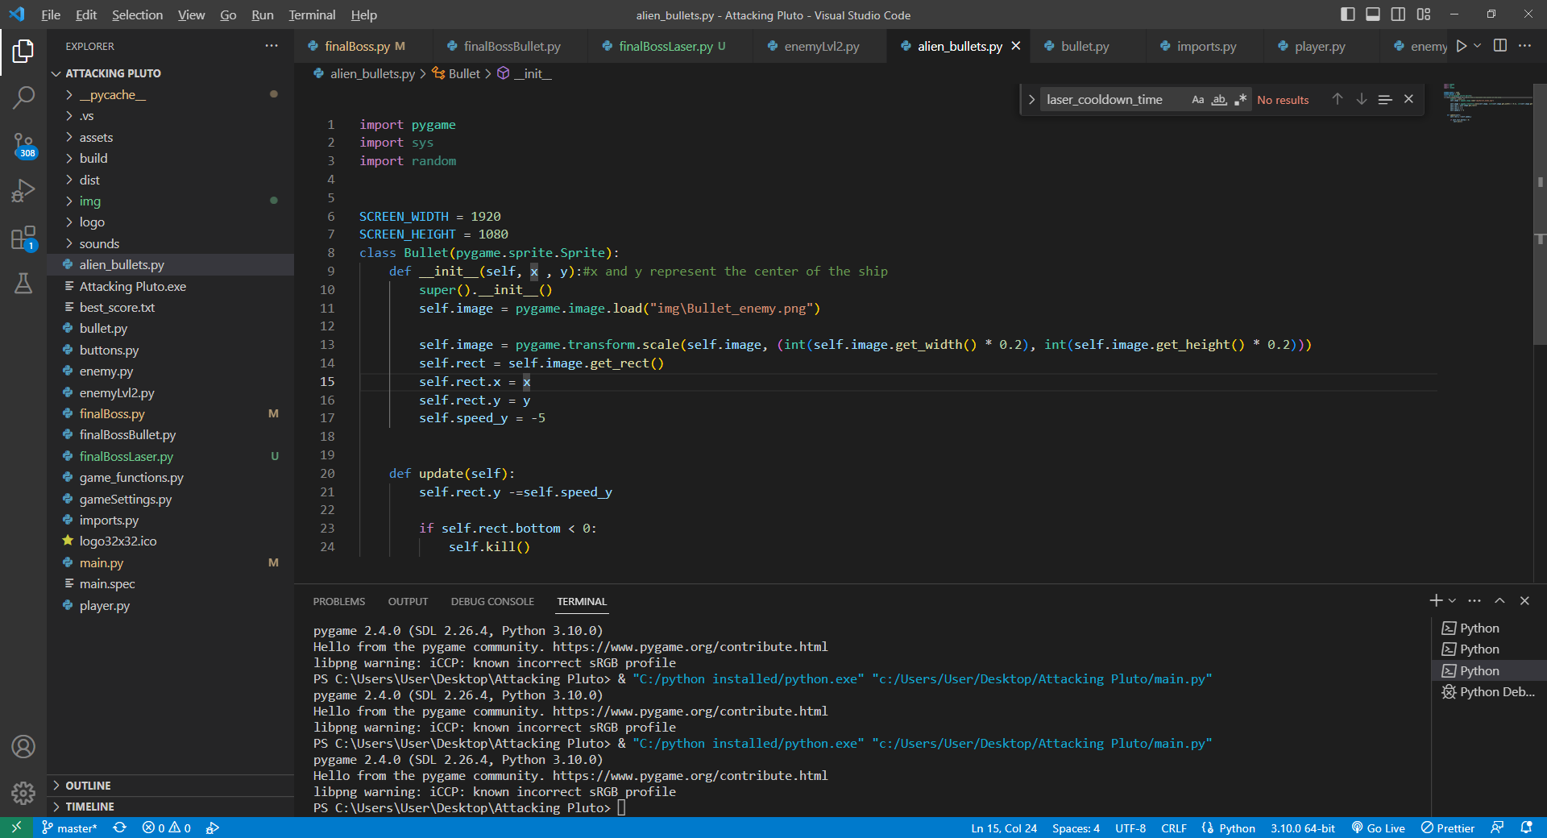

-Everything is self explanatory here: This is a bullet that flies from the alien that comes from the top of the screen to the player.

*bullet.py

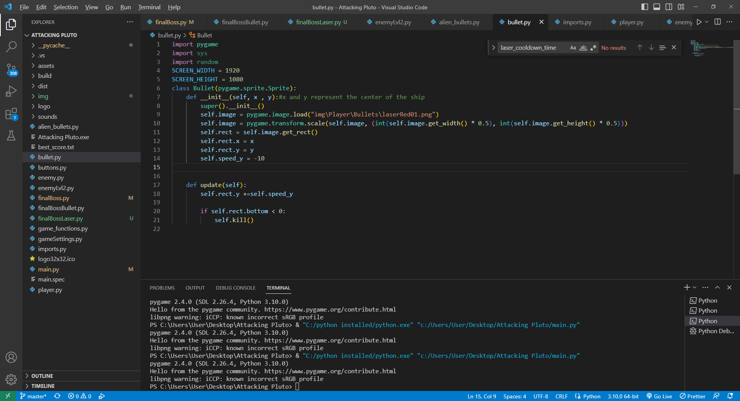

-Same as previous class, only difference is the speed

*buttons.py

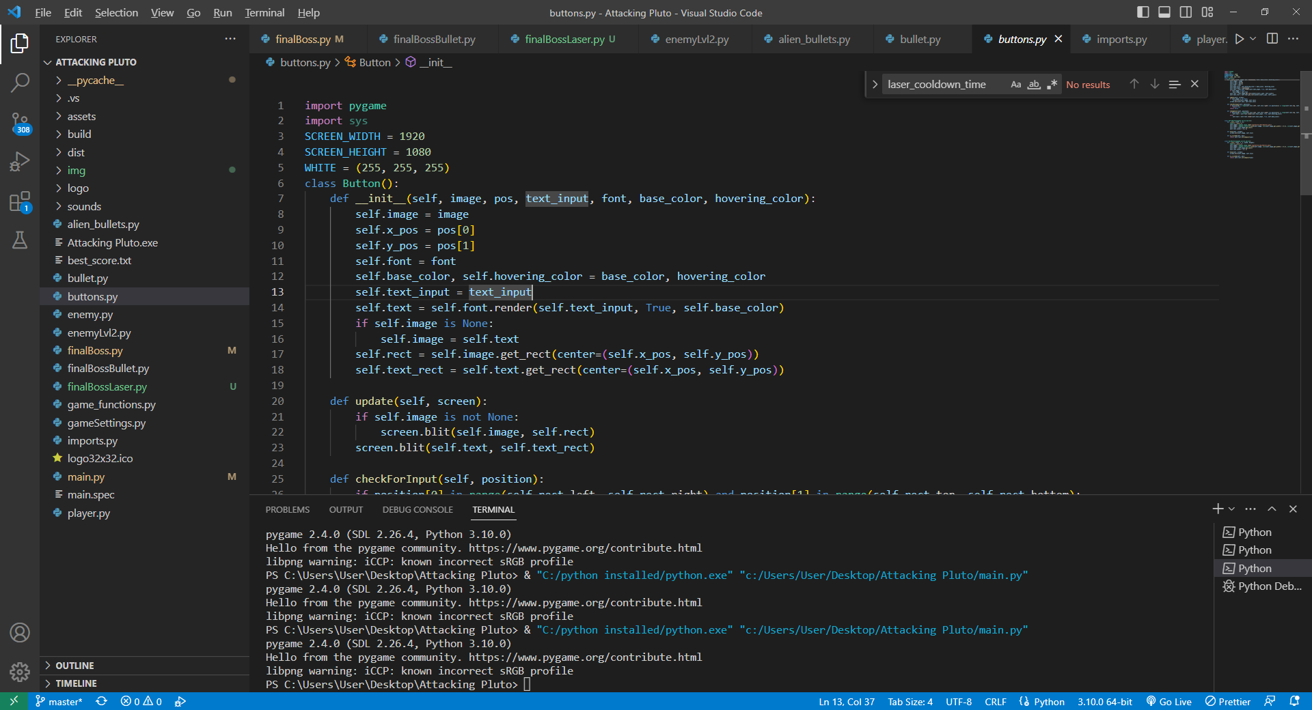

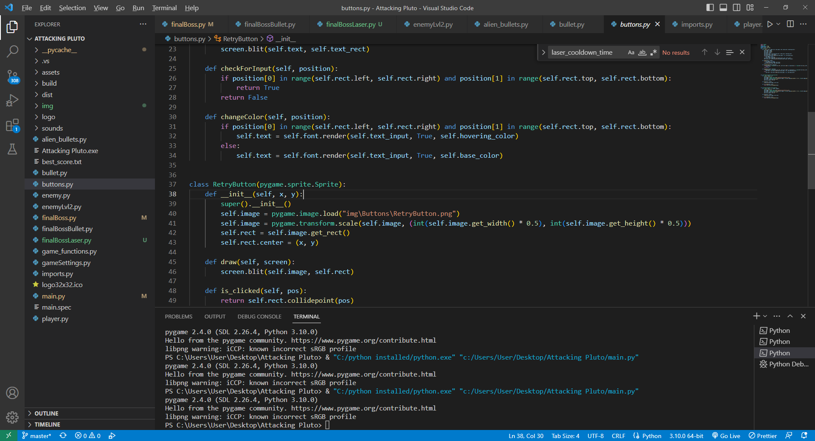

-Button – has base color, if hovered it changes it’s color. Update draws it on the screen. checkForInput checks if you click on the button, then something happens (depends on the situation). changeColor – changes the color of the button when hovered.

Retry and Quit buttons -

*enemy.py

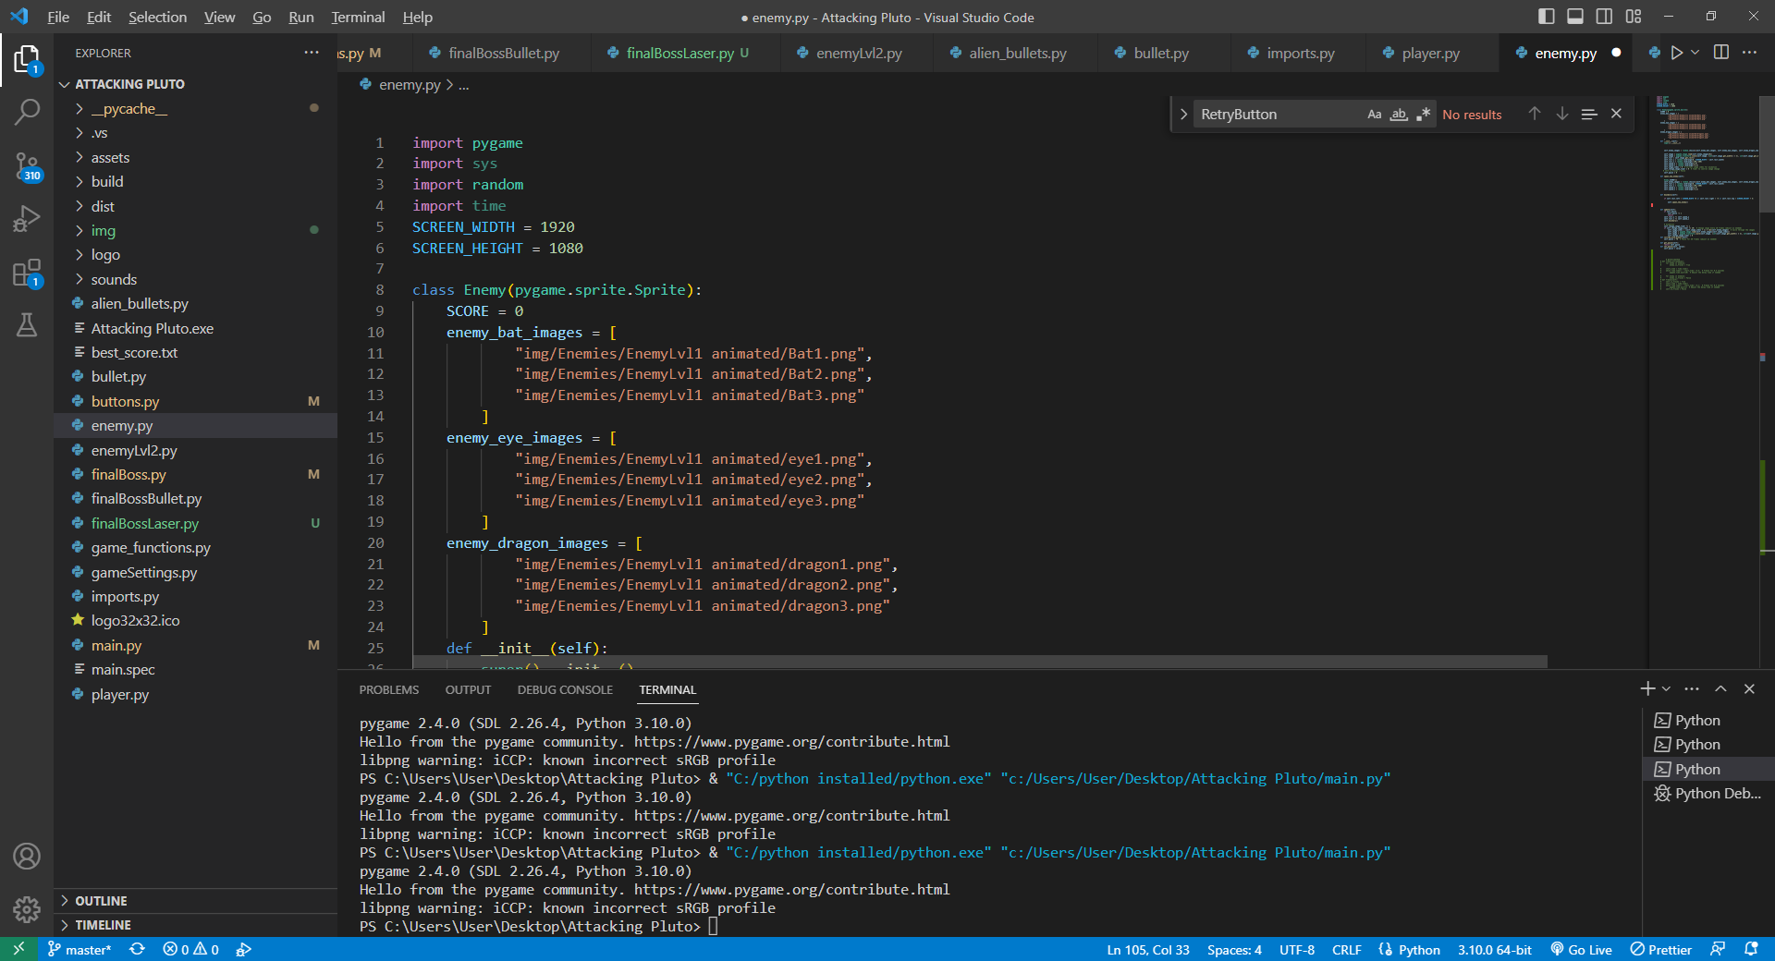



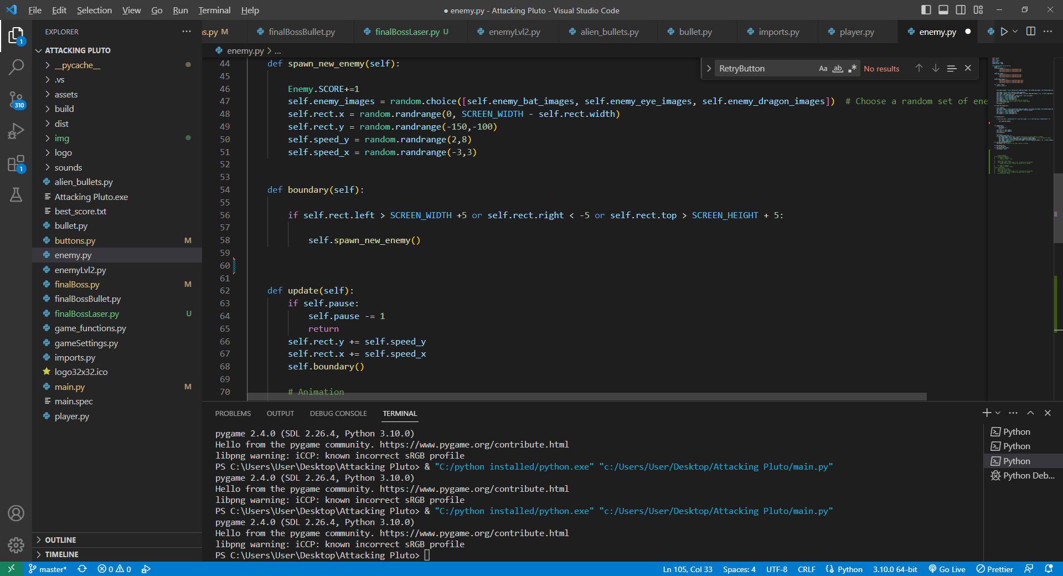

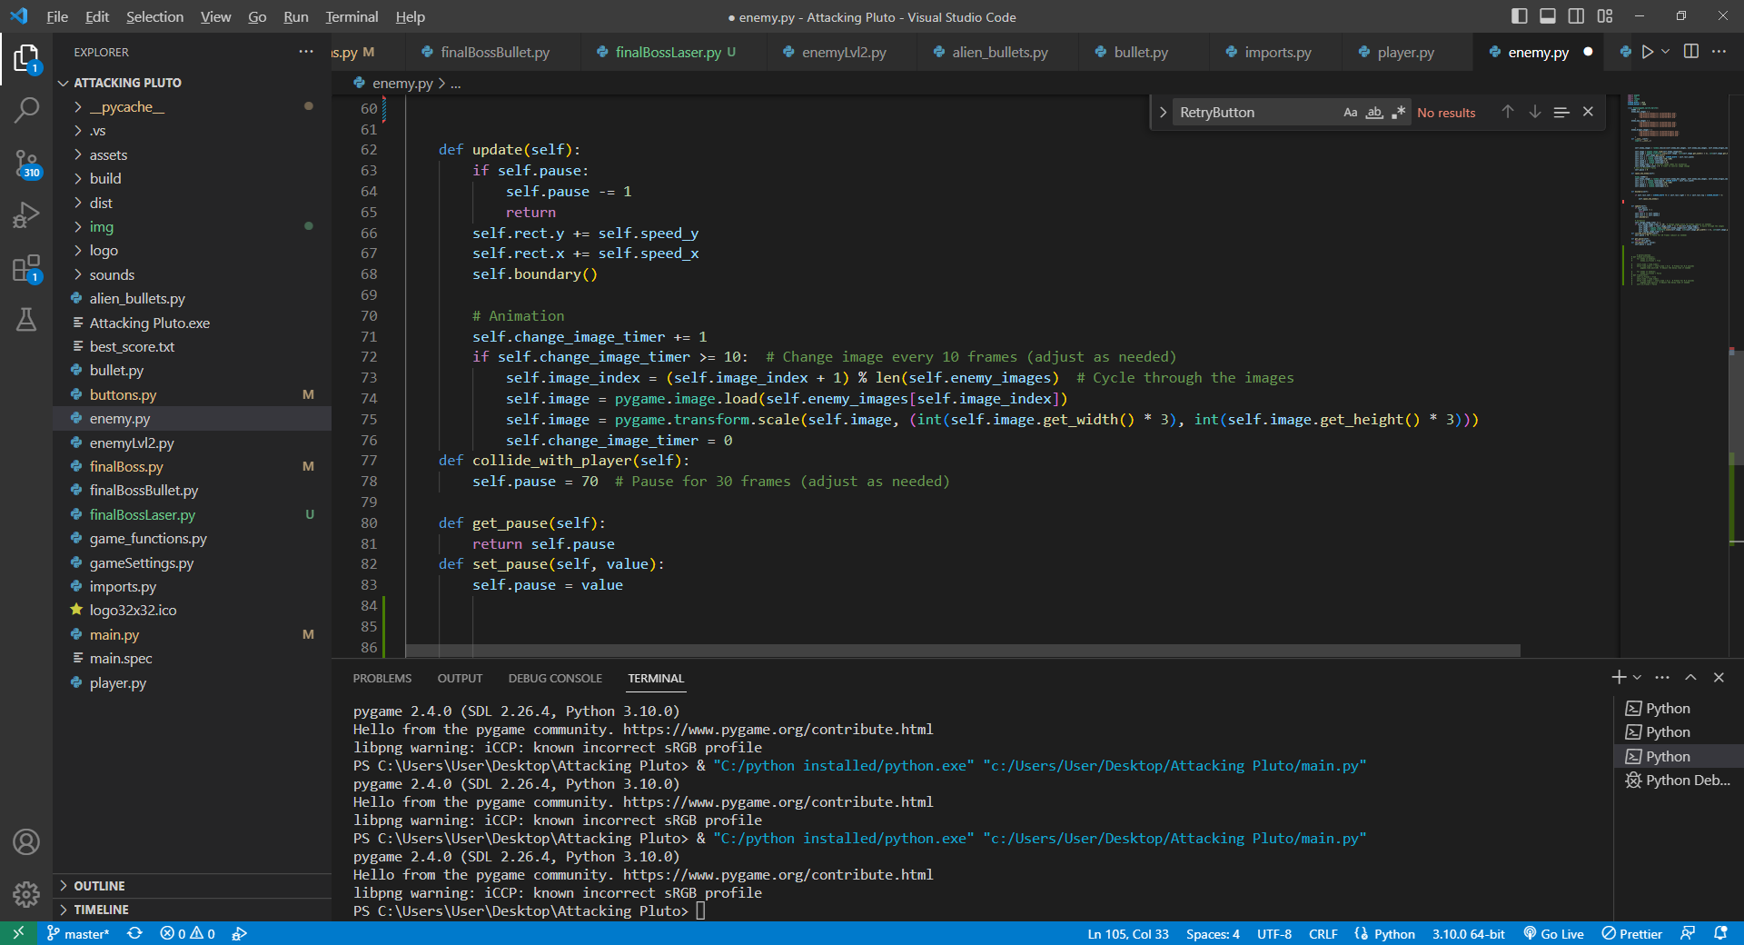

-There are 3 different enemies, they fall from the top of the screen with random speed. spawn_new_enemy – spawns new enemy randomly at the top of the screen.

Boundary- if the enemy go off the screen a new one is spawned.

Update – updates the position of the enemy and animates the enemy.

*enemyLvl2.py

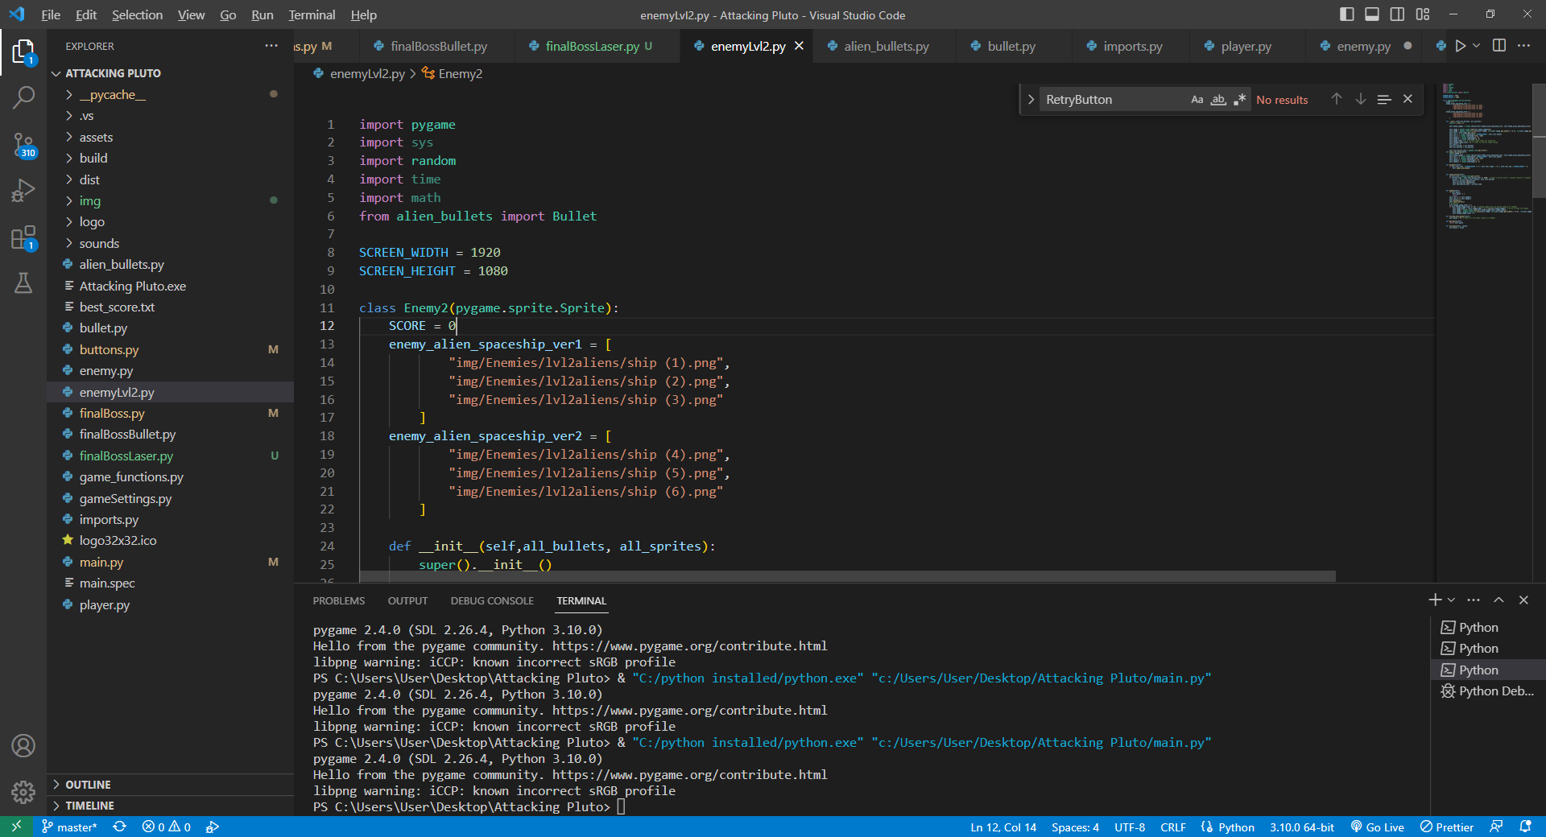

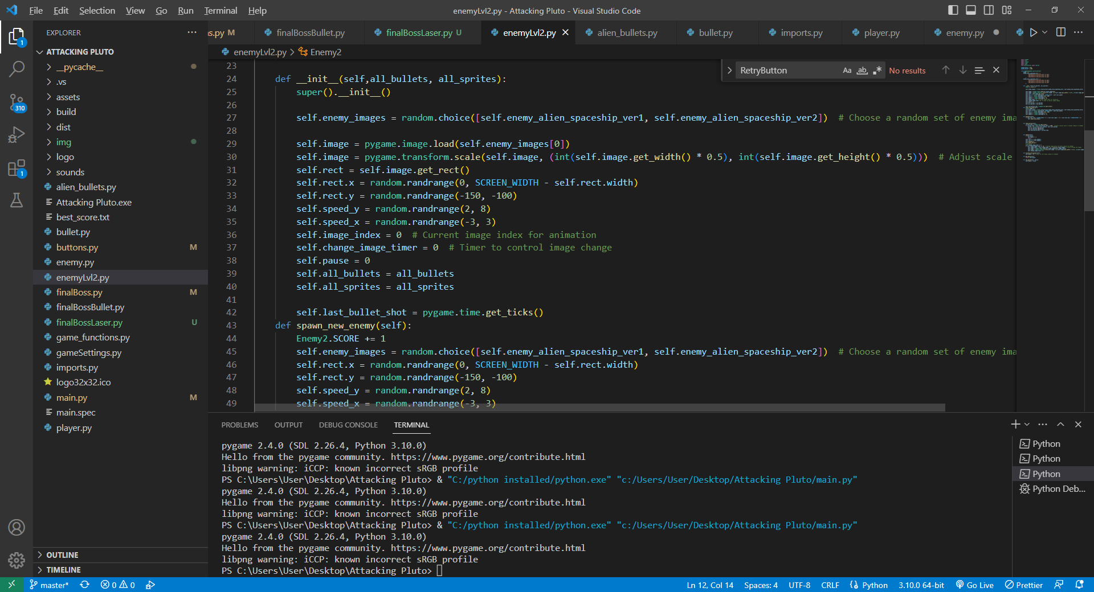

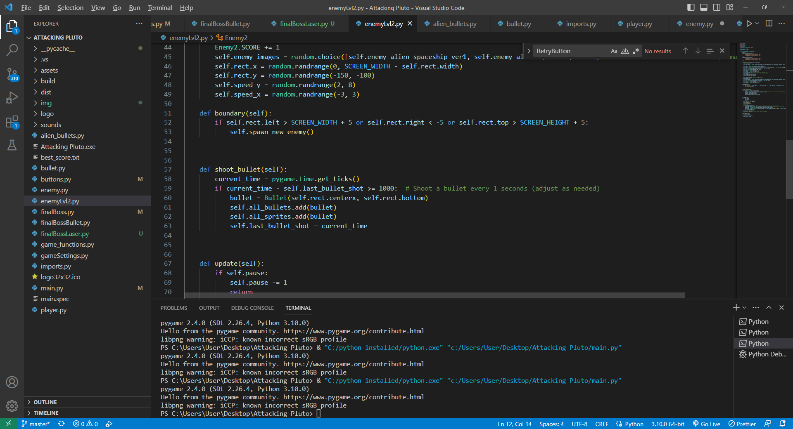

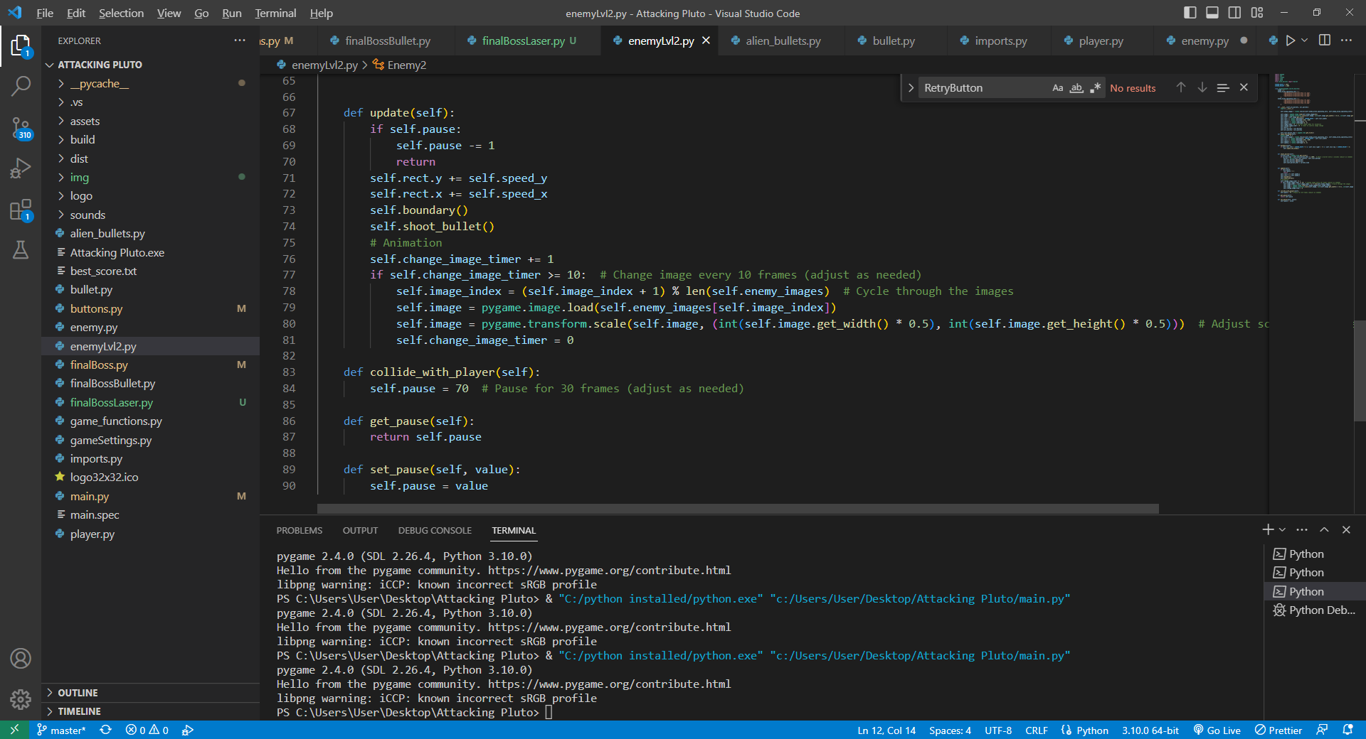

-Almost the same as enemy.py, only difference is that it shoots a bullet every 1 second.

*finalBoss.py

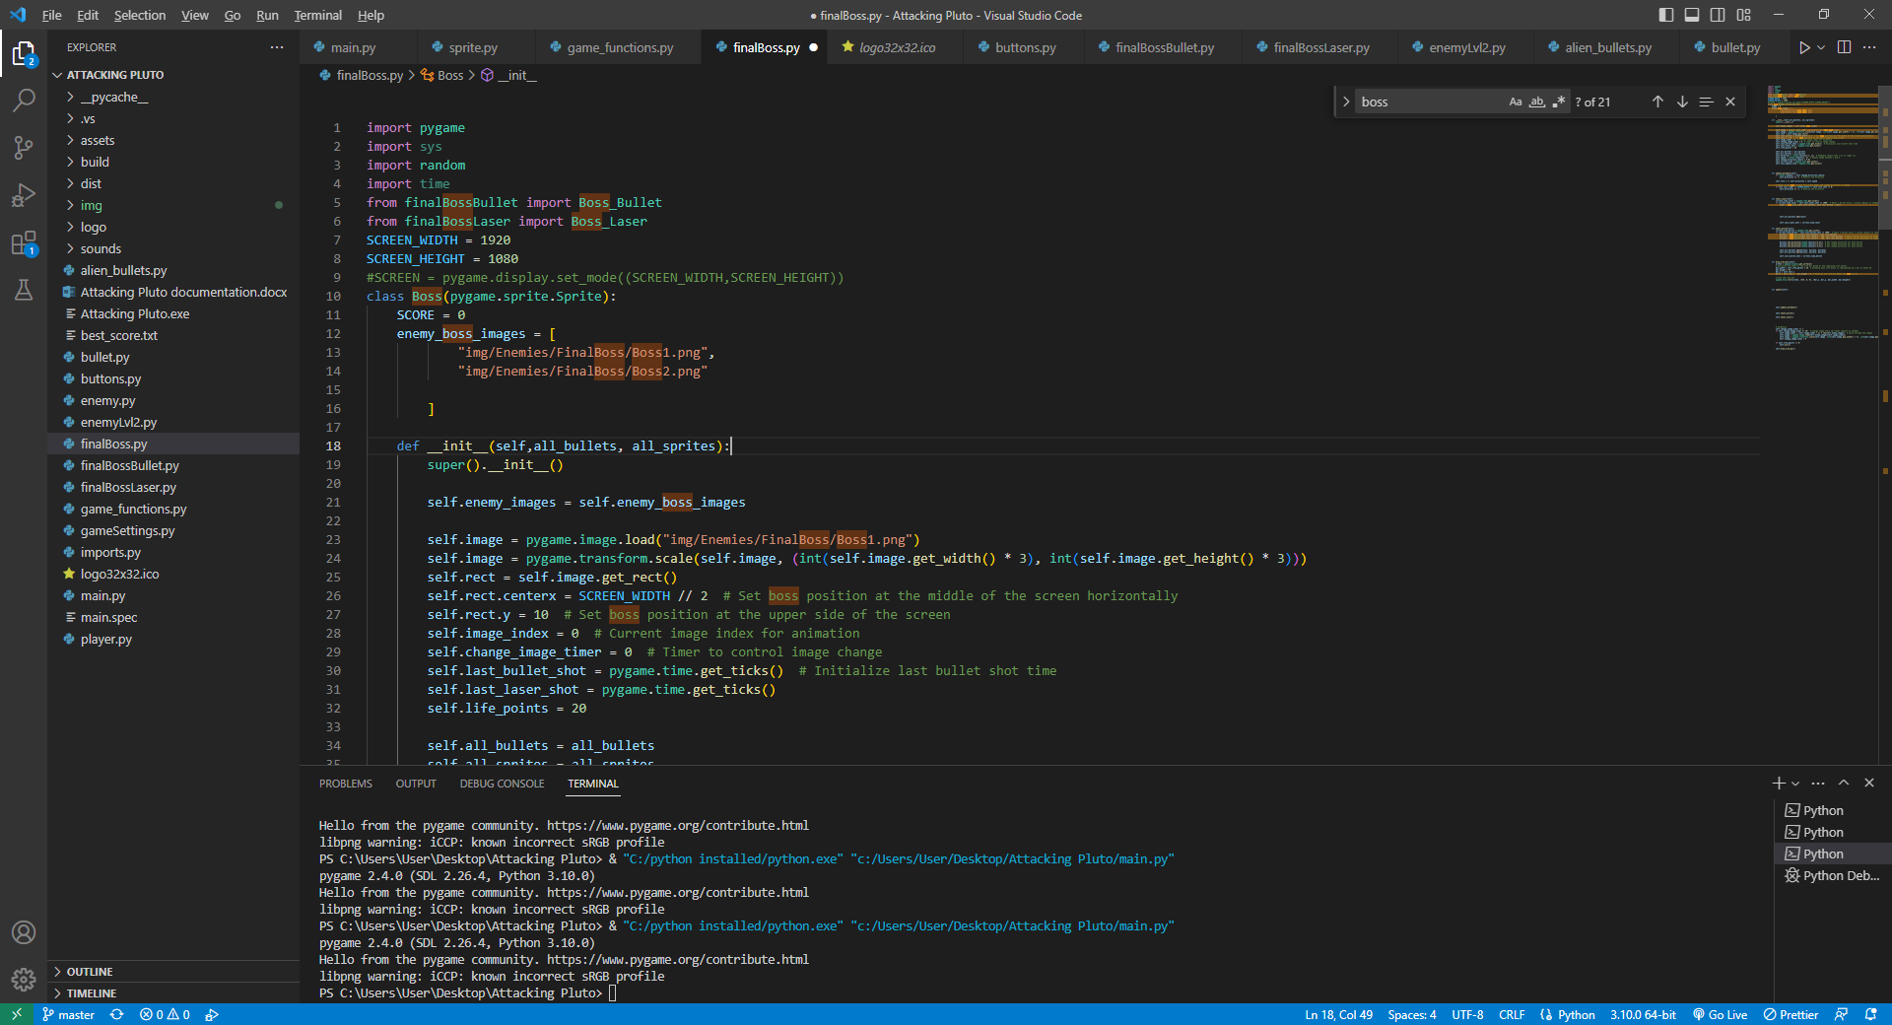

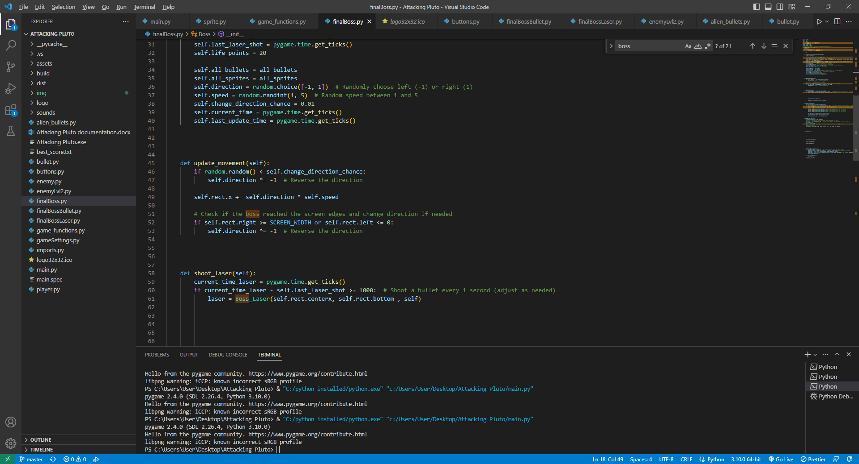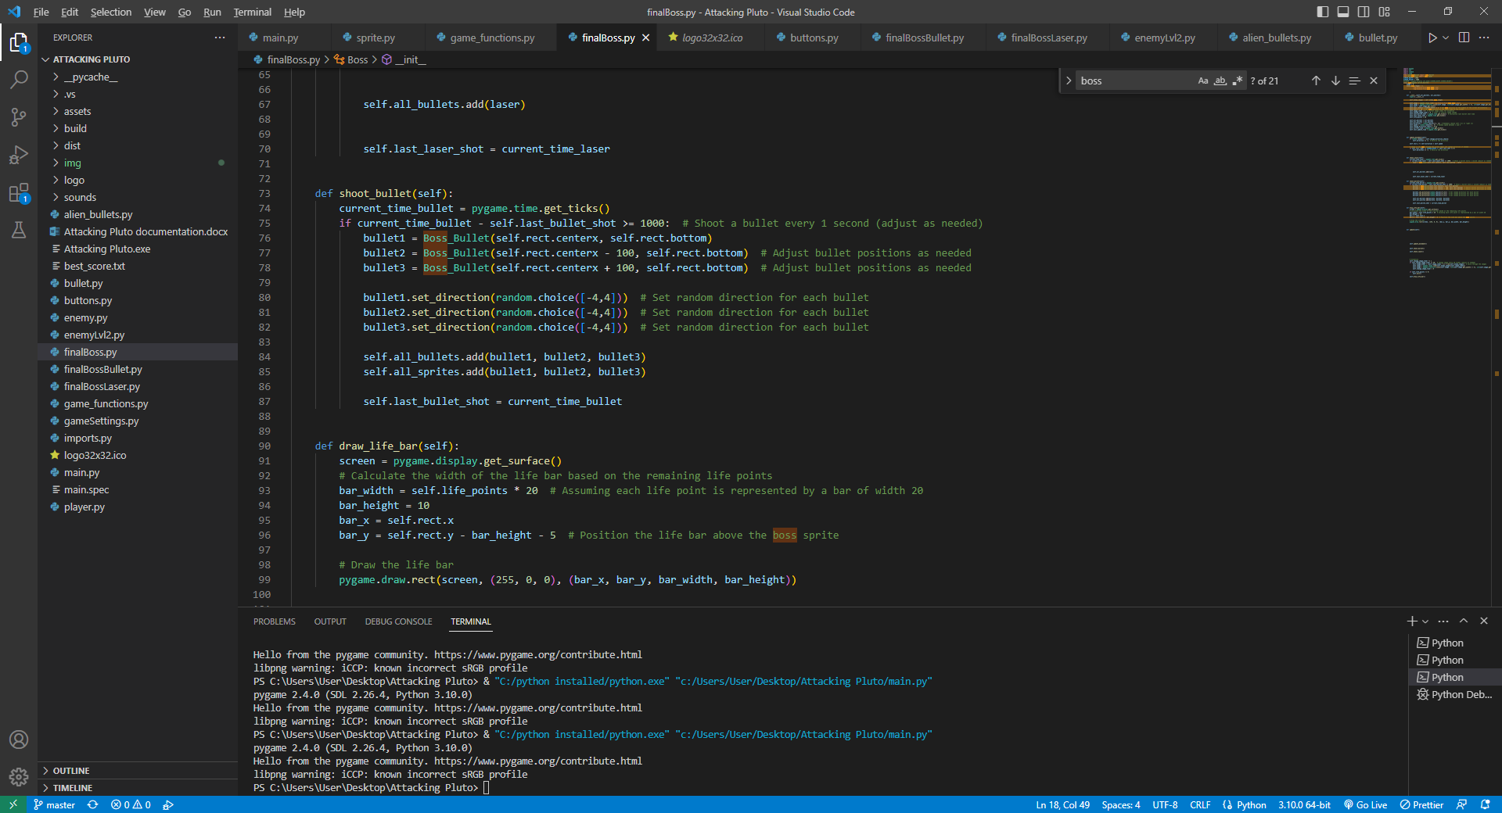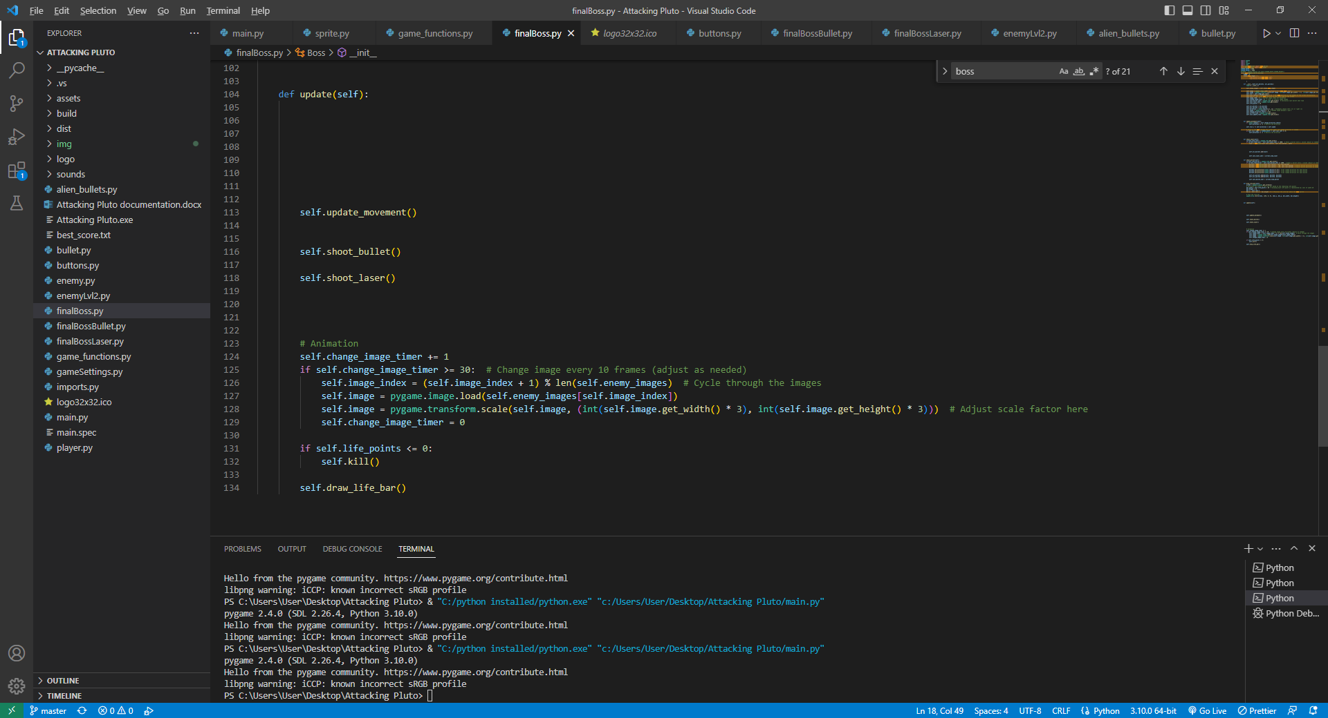

The final boss is animated, he has 20 life points and he moves with random speed to the left or to the right. He can change direction any time. If he touches the left or the right side of the screen, he changes the direction he is going to. shoot_laser method does not work for some reason… I wanted him to shoot a big laser. shoot_bullet method is implemented so he shoots 3 bullets that are animated at a random direction. draw_life_bar – draws his life bar which consists of 20 points, it is position just above the boss. The update method updates the position of the boss and shoots bullets, but unfortunately it does not shoot lasers. The boss dies if his life points are 0.

*finalBossBullet.py

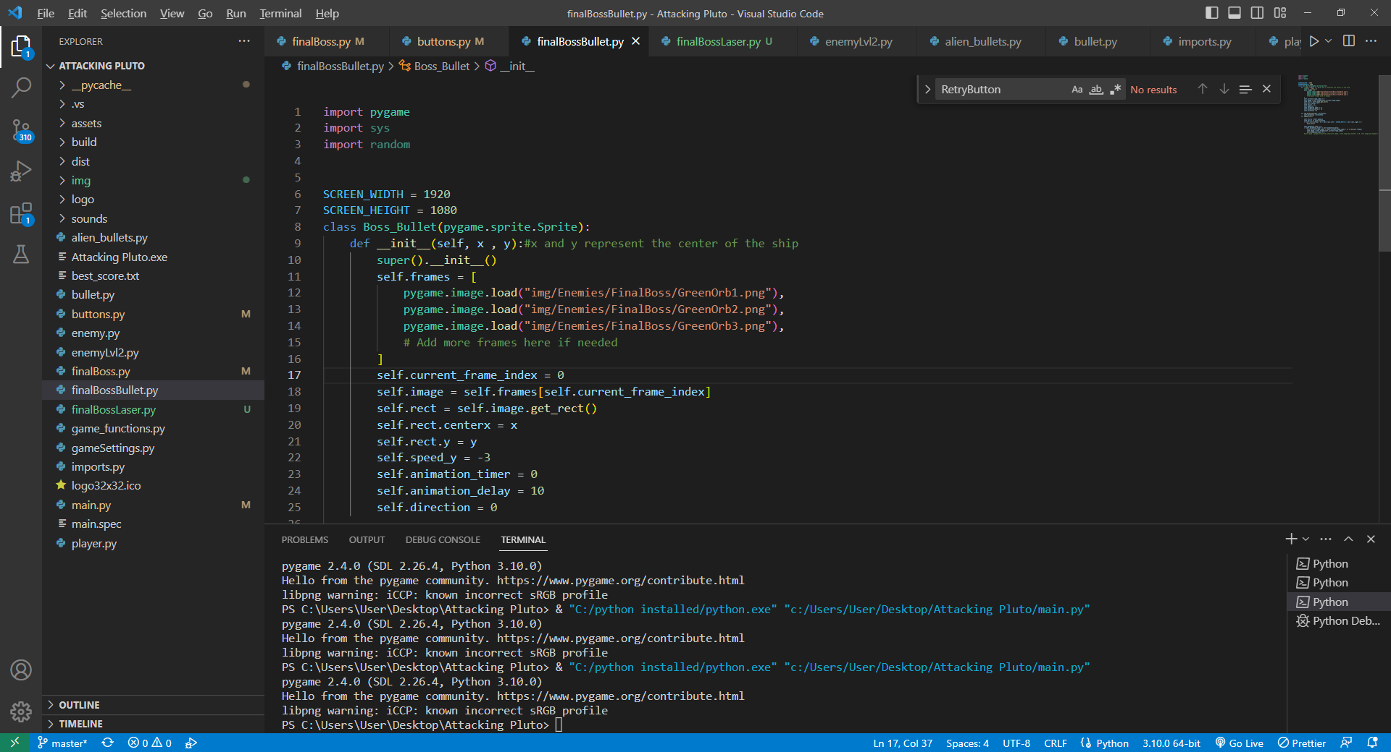

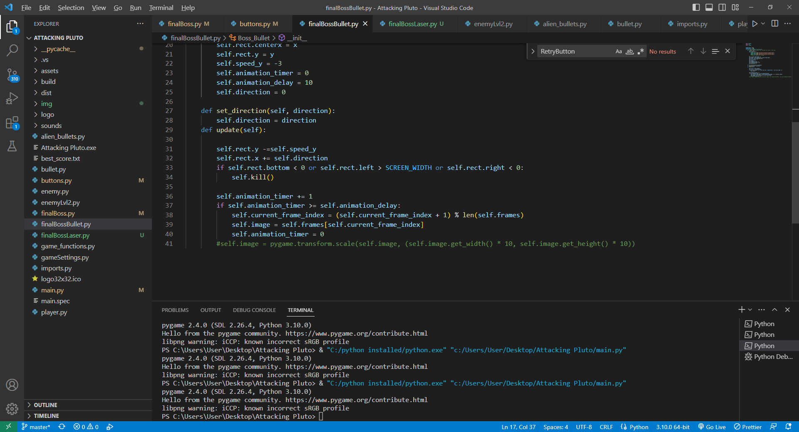

-Very similar to bullet.py/alien_bullets.py, Only difference is that it moves slower and there is animation when it gets shooted.

*finalBossLaser.py

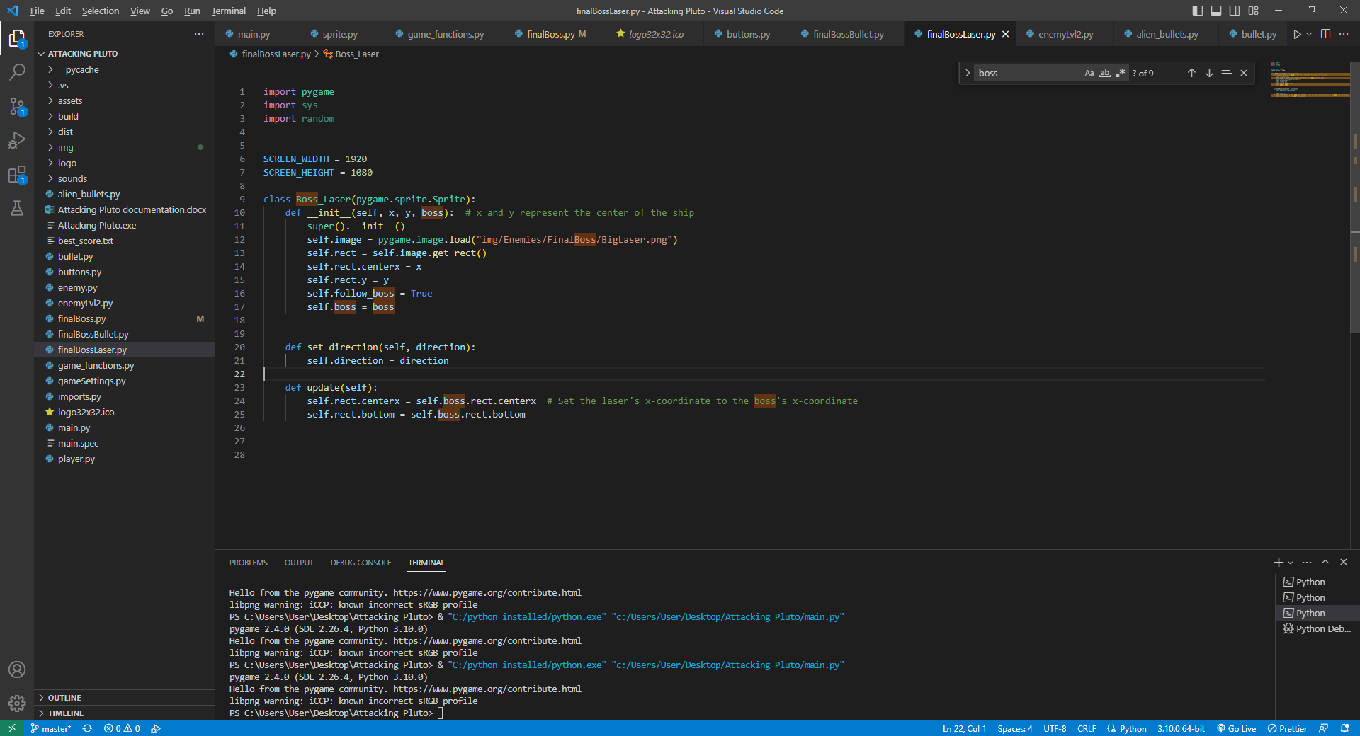

Unfortunately, for some reason this laser can’t appear on the screen. I wanted to use it in the boss class. I wanted the laser to come from the bottom of the enemy and to follow him.

*game_funtions.py

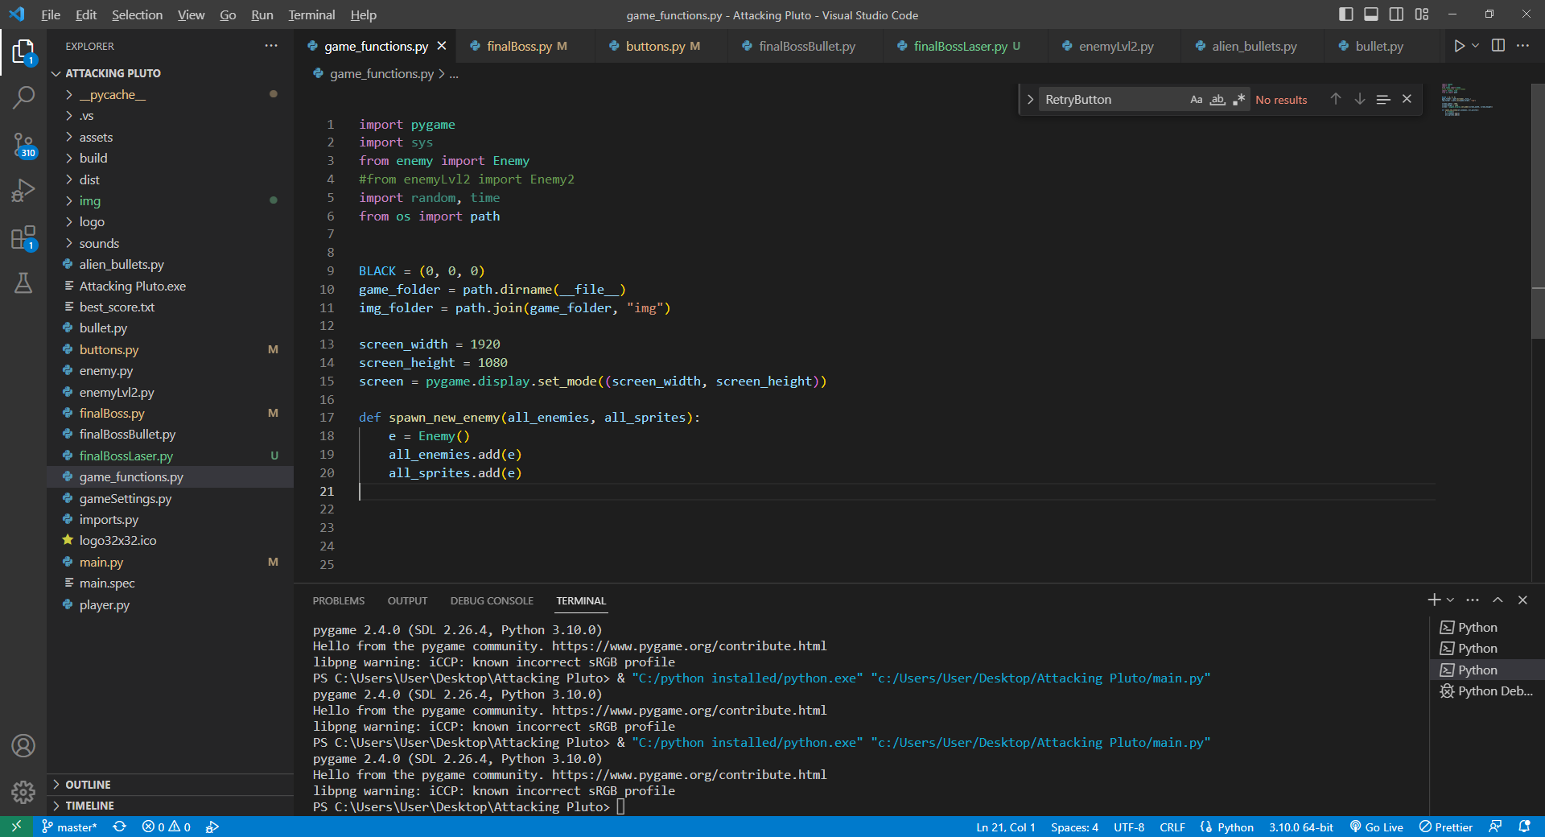

-Nothing much, spawn_new_enemy – spawns a new enemy and adds it to 2 groups

*gameSettings.py

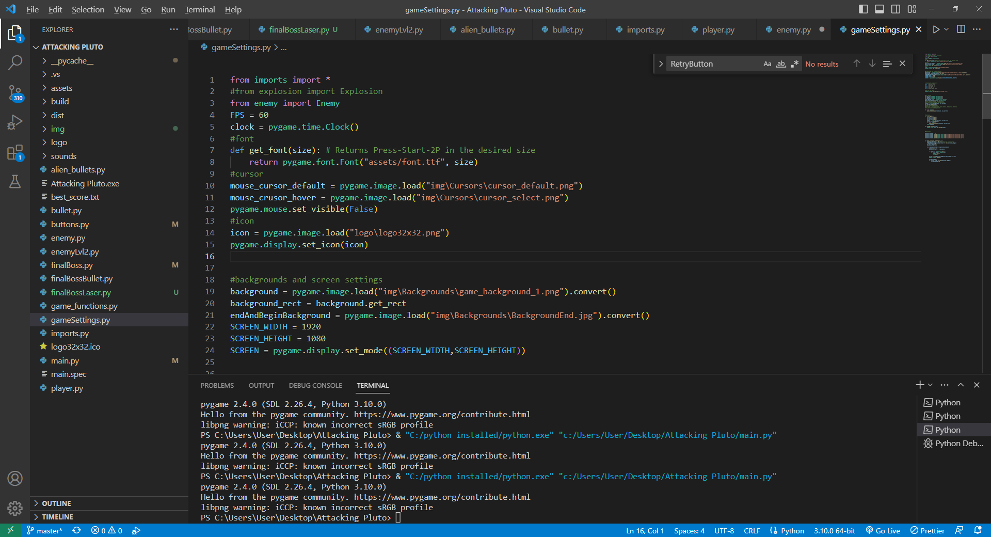

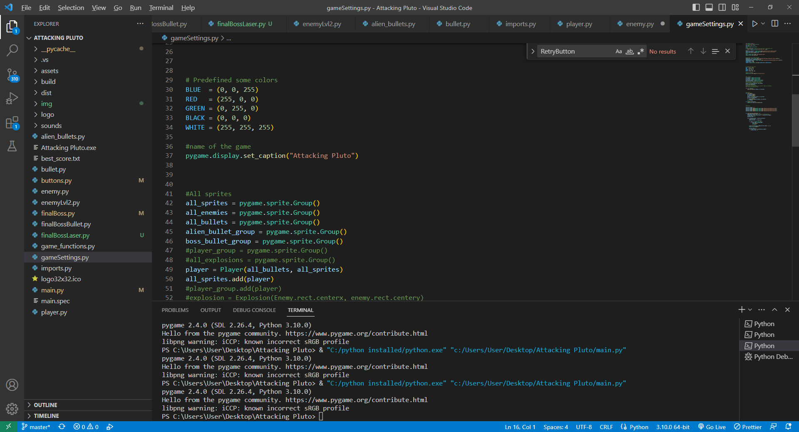

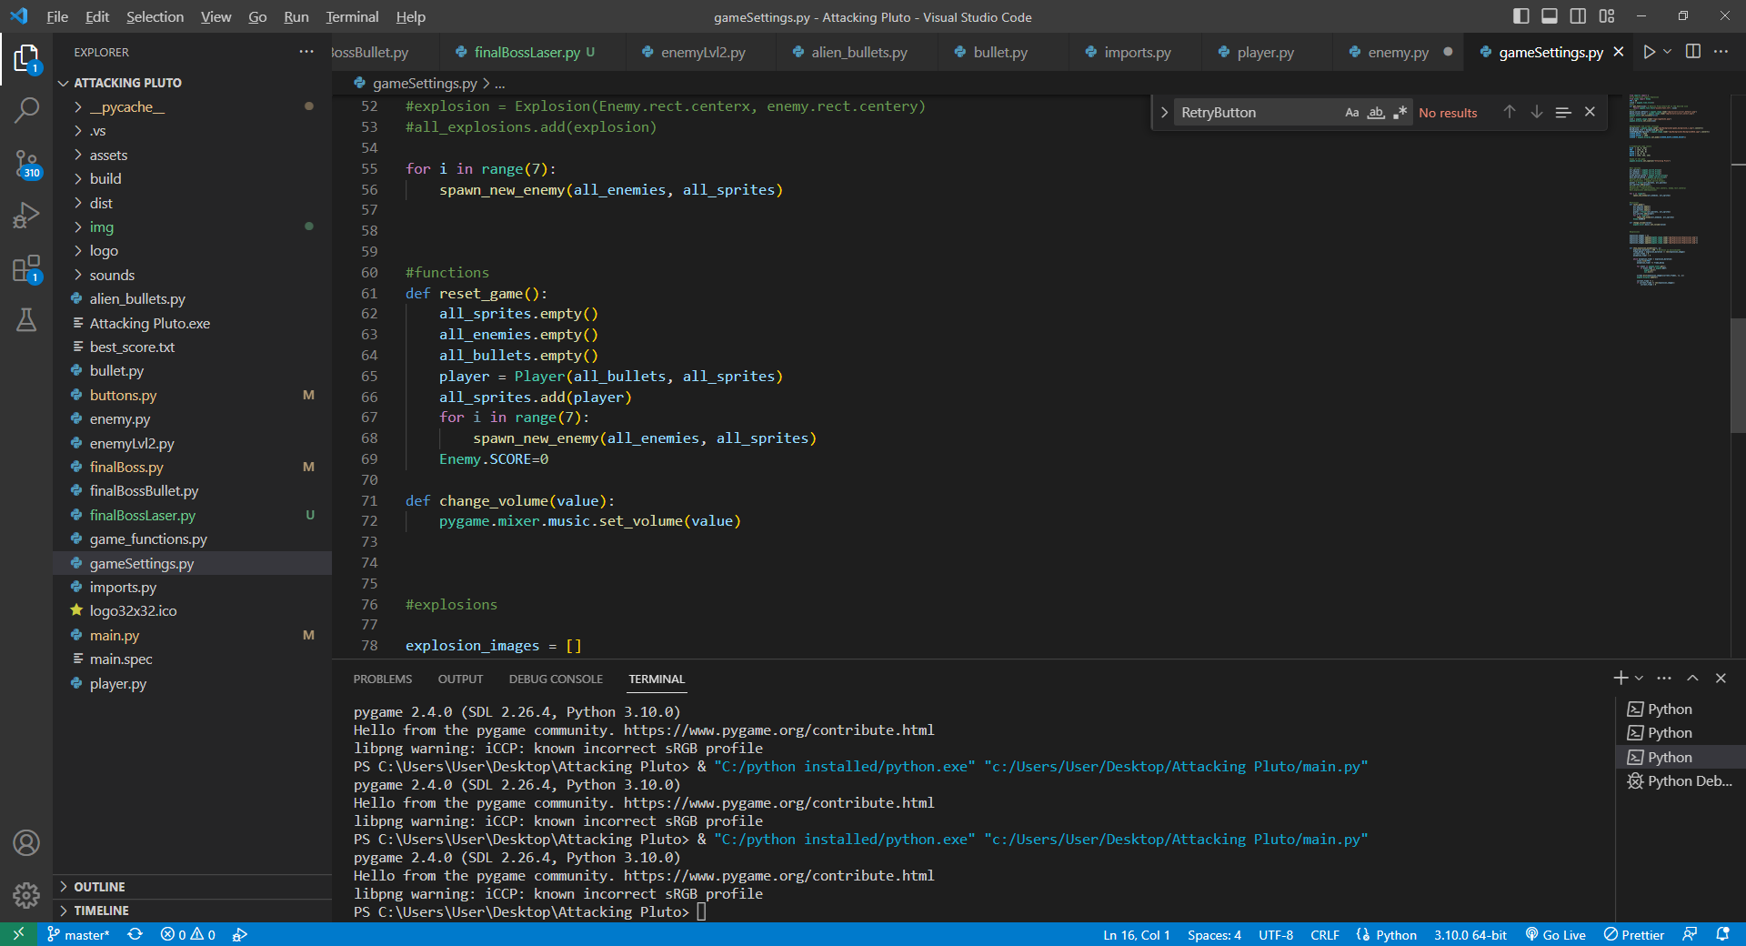

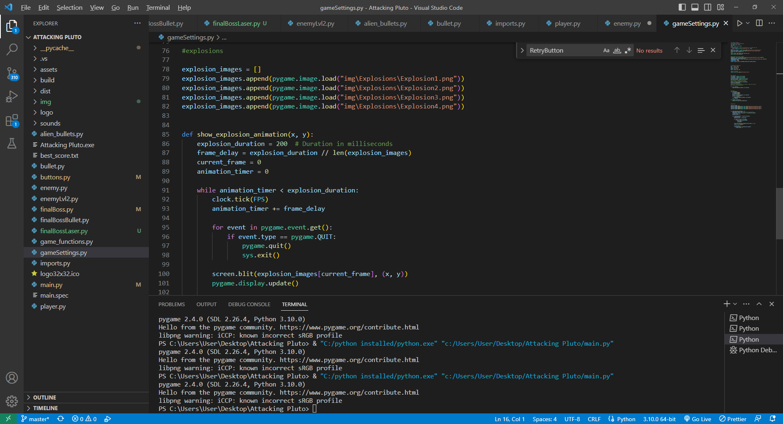

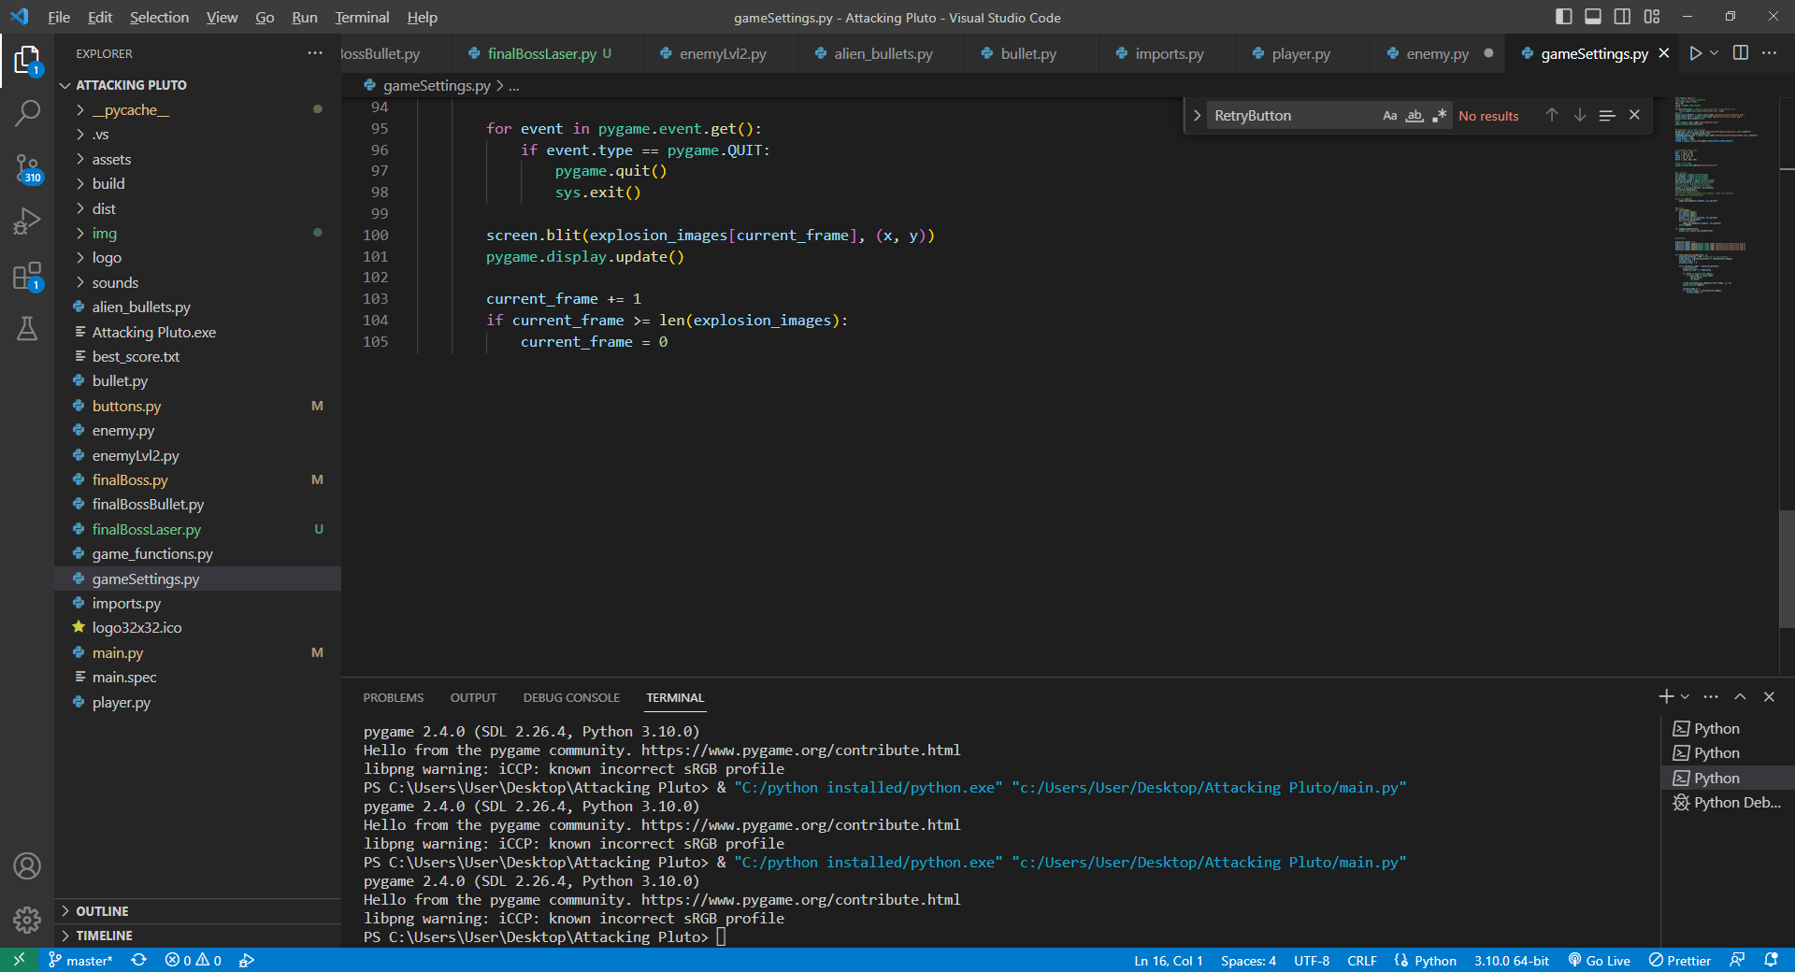

-Fonts, mouse cursors, Icon. Background, some predefined colors, groups, reset game function that empties all groups and fills them up again. show_explosion_animation – explosion animation that can be seen when the player shoots an enemy sprite

*imports.py

- Helper class that consists of imports

*main.py(no photos, because there is too much code)

This is the most important class that is constructed of 2 menus -main menu and death menu and one options method for turning up or down sfx and music volume.

Main menu- consists of 3 buttons – Play, Options and Quit.

Play – to play the game

Options – change volume

Quit – quit

Death menu – Menu,Retry,Quit

Menu – sends you to main menu

Retry – Starts the game from the first level.

Quit- quit.

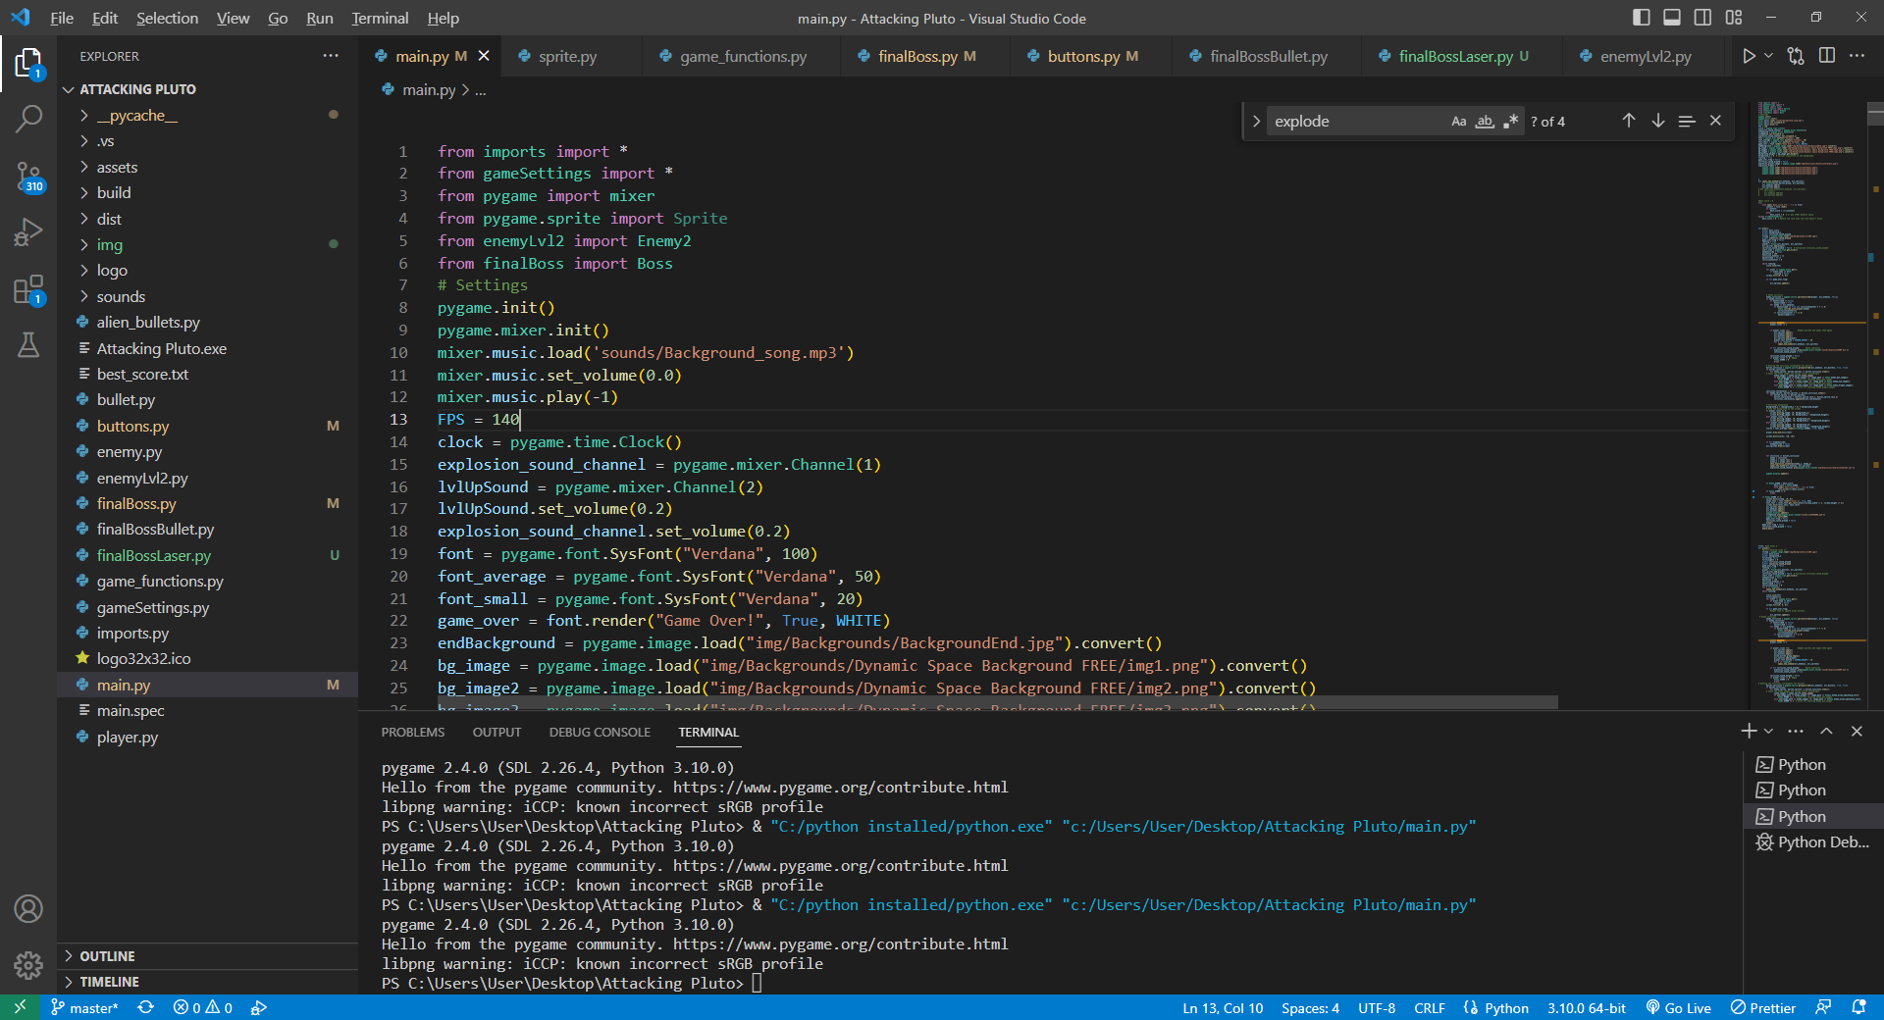

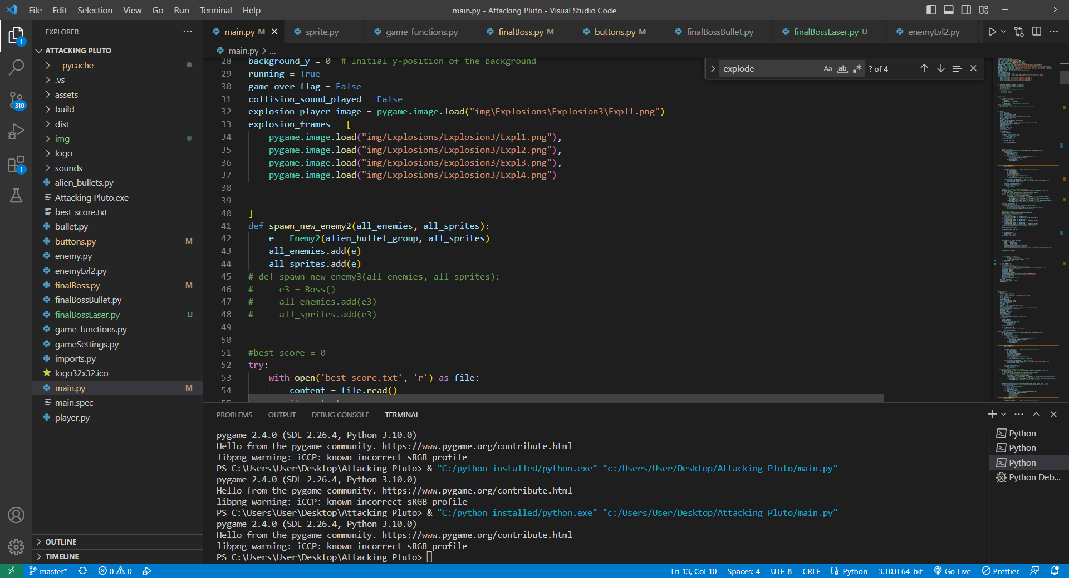

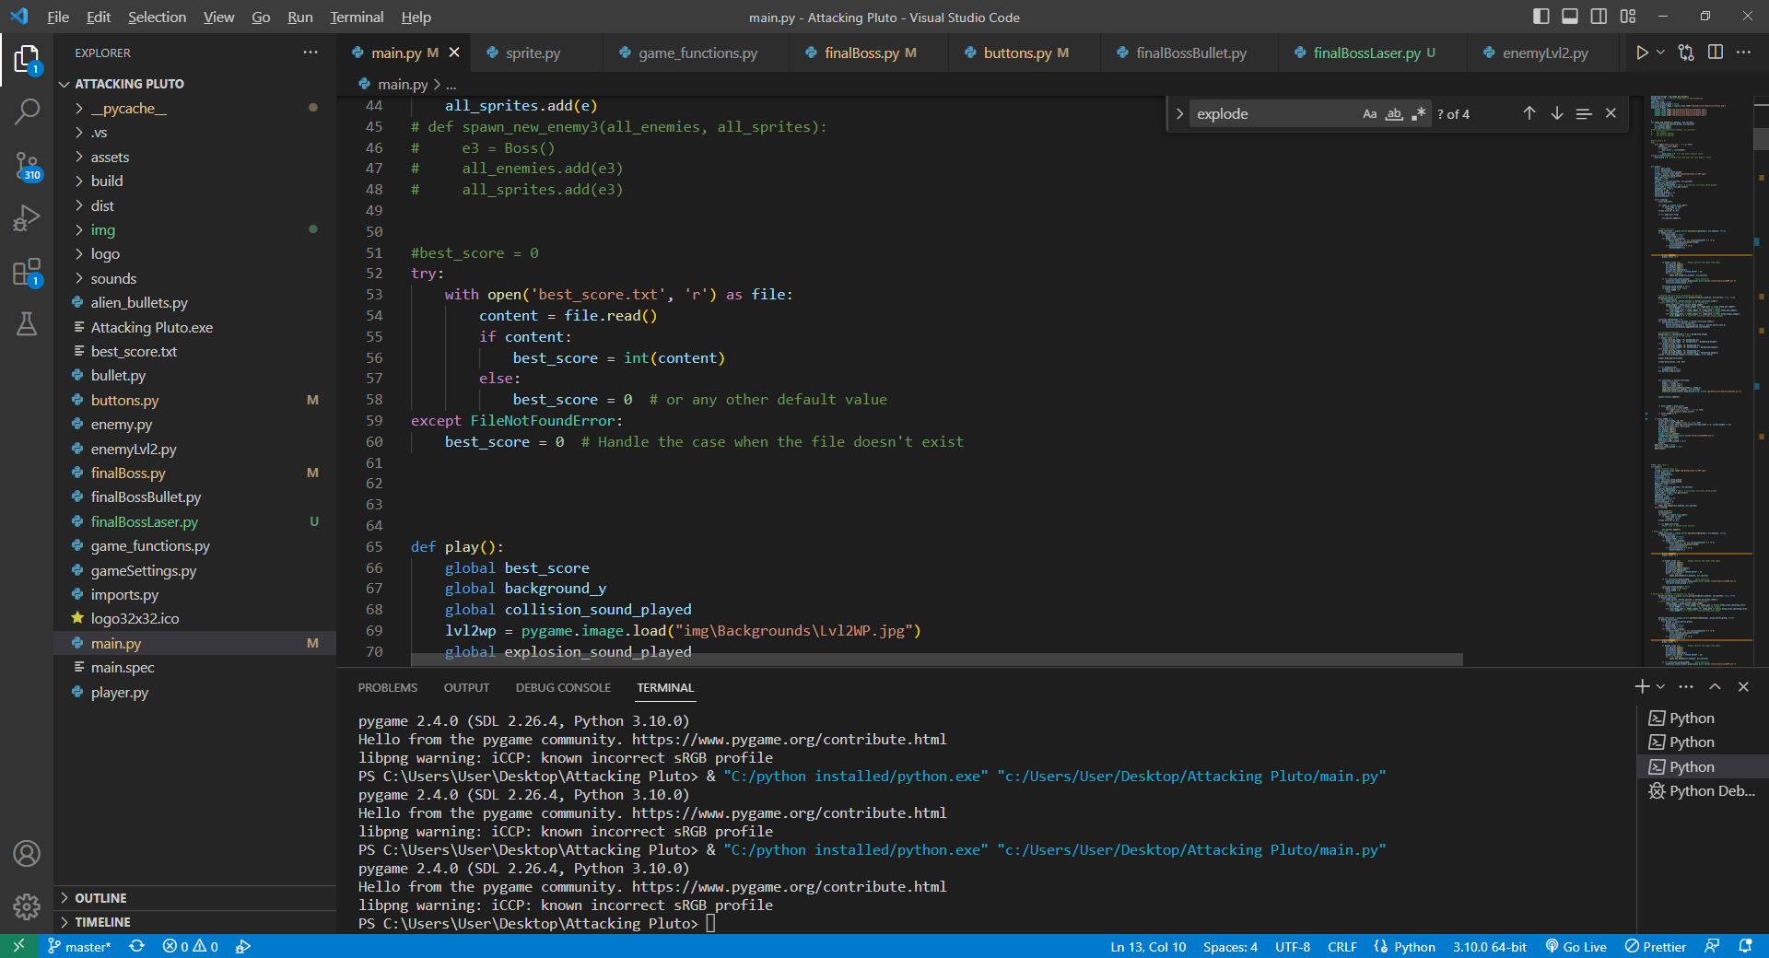

These are some settings needed for the game to work. Also there is implementation for best score algoritm that is used in the play,play2,play3 methods (the levels).

Every level consists of while running loop. There is event getter, Enemy collision algorithm that detects collision between player and enemy and restarts the game and decrements player’s lives. It also plays a special explosion sound. There is bullet collision algorithm that detects collision between enemy and a bullet and adds different amount of points depending on the enemy kind. The background changes depending on the player’s lives. When enemy collides with a bullet it respawns.

If you get higher score than usual there is algorithm that changes the best score. After completing each level there is a winning sound and a level up image appears on the screen. The difference between level 1 and level 2 is that in level 2 there are only 4 enemies spawned but they have their own bullets and they shoot them every one second. You still get points if the enemies go off the screen or if you shoot them.

The final boss is at level 3. The final boss shoots 3 bullets at the player randomly across the screen. He has 20 life points, each time he gets shot, he loses 1 point and the point is added to the player’s points. If you collide with the boss you lose a life point. If you win you get transferred to the winner screen.

*player.py

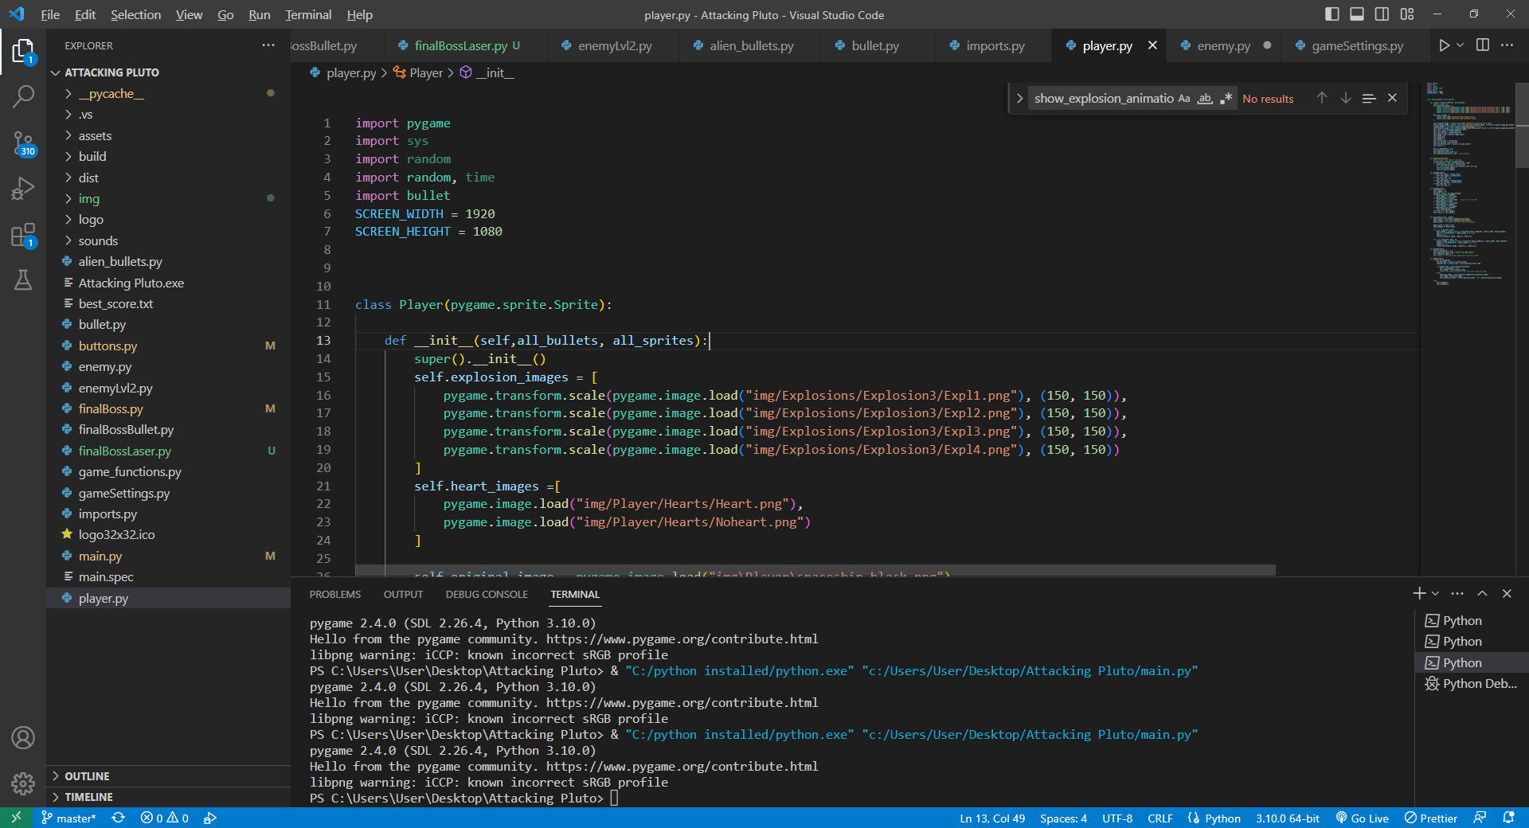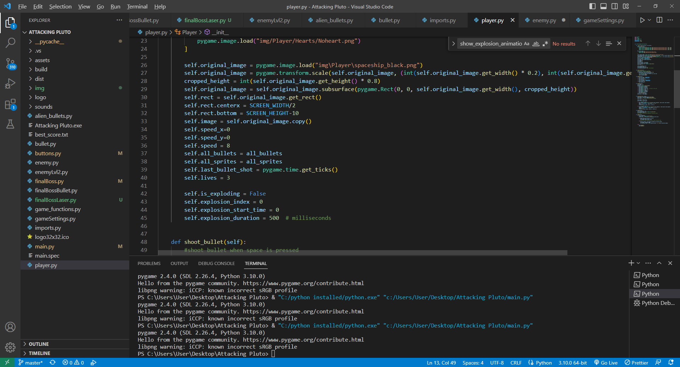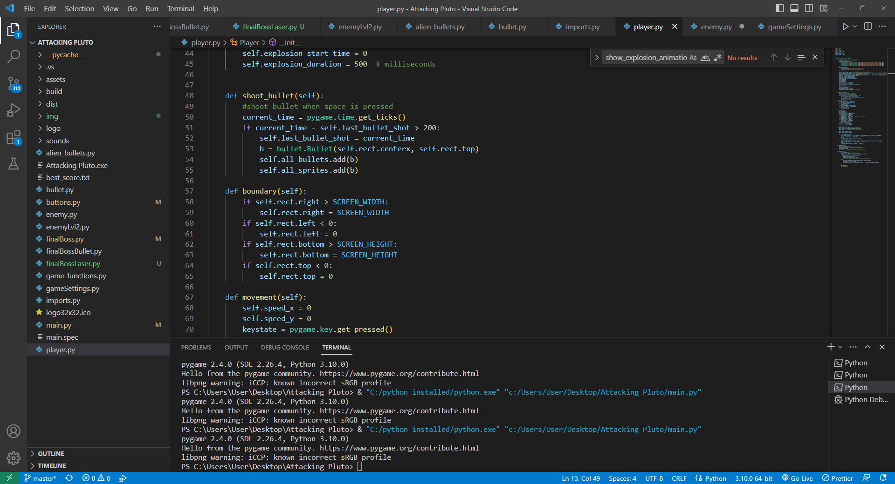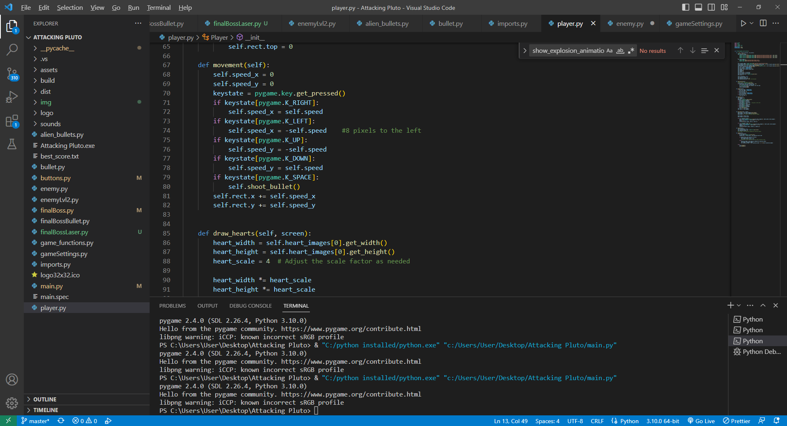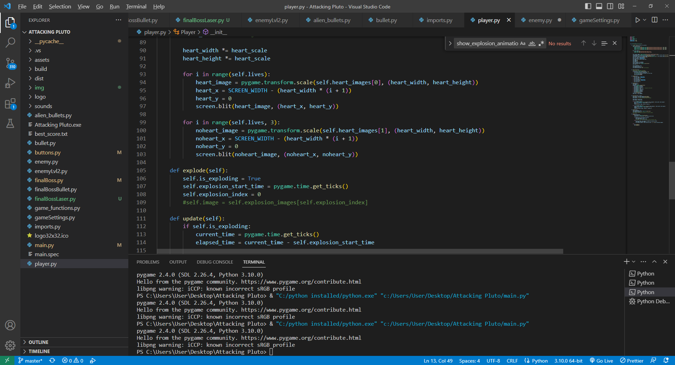

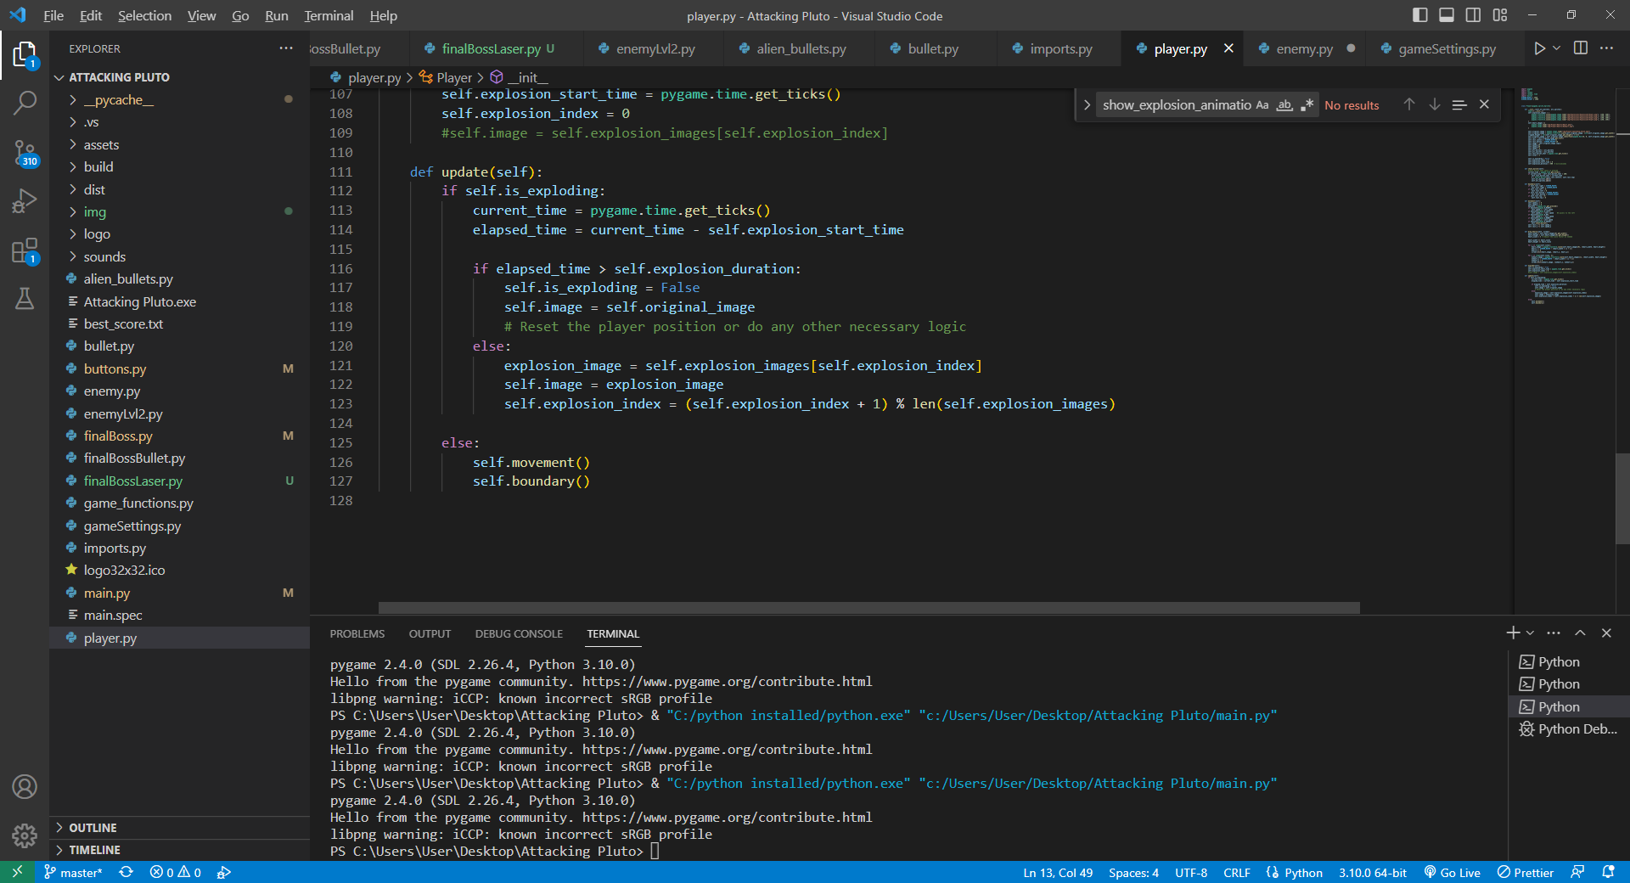

-The player spawns in the center, he has 3 lives, moving speed, animation for explosion, full and empty heart images.

He can shoot bullets, and boundary function sets a boundary for the player – he can’t go off the screen. Movement method implements the way he can move – up,down,left,right. Draw_hearts draws the hearts.Update updates the player position or shows the explosion that happens when he collides an enemy.